Shell-2010-Pecten-RGBpc.wmf

**Onshore Engineering Nigeria**

**(Operations Support & WRFM)**

**Obigbo NAG to AGG Rerouting_Technical Feasibility Study Report**

Alaka Olanrewaju

Trainee Process Engineer

April 2018

Revision Number: A01

Document Number: **SPDC-2018-04-00000057**

This document is made available subject to the condition that the recipient will neither use nor disclose the contents except as agreed in writing with the copyright owner. Copyright is vested in Shell Petroleum Development Company Ltd. © All rights reserved. Neither the whole nor any part of this document may be reproduced or distributed in any form or by any means (electronic, mechanical, reprographic, recording or otherwise) without the prior written consent of the copyright owner.

Up to two lines if required

Security Classification: Restricted

Security Classification: Restricted

**Revision History**

|  |  |  |  |  |  |
| --- | --- | --- | --- | --- | --- |
| **REVISION STATUS** | | | **SIGNATORIES** | | |
| **Rev.** | **Date** | **Description** | **Originator** | **Reviewer** | **Approver** |
| R01 | Mar 2018 | Issued for Review | A. Olanrewaju | B. Rasheed |  |
| A01 | April 2018 | Issued for Approval | A. Olanrewaju | B. Rasheed | E. Tonye |
|  |  |  |  |  |  |
|  |  |  |  |  |  |
| * Preliminary issue will be issued as P01 * Revisions for review will be issued as R01, with subsequent come as R02 etc. * Revisions approved for Implementation/Design Issue/Eng. will be issued as A01, with subsequent come as A02 etc. * Revisions approved for Tender will be issued as T01, with subsequent come as T02 etc. * Revisions approved for Construction (AFC)/Purchase will be issued as C01; with subsequent comes as C02 etc. * Highlights of sections revised from previous approved issues or reasons for version change are to be listed in the description box * All revisions to this document must be signed by the relevant Technical Authority (TA1, TA2 or TA3) | | | | | |

**Signatures for this revision**

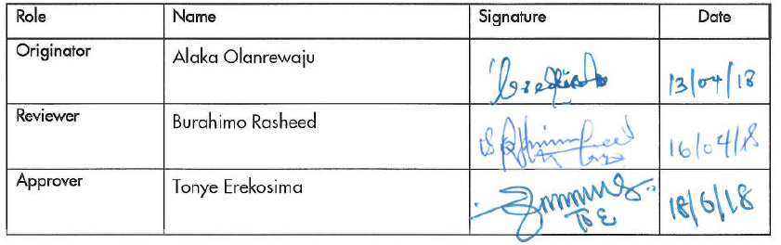**Contributors:**

Idio Samuel Principal Rotating Equip. Engineer, Discipline Lead Mechanical

Wokoma Esther Field Team Leader (Mtce), Obigbo Operations

Olowononi Joshua Field Supervisor (Operations), Obigbo Operations

Onumajuru Chukwuka Field Technician (PACO), Obigbo Operations

Ejirinde Adeyemi Field Supervisor (PACO), Obigbo Operations

Table of Contents

Executive Summary 4

1. INTRODUCTION AND BACKGROUND 7

1.1. OBJECTIVES 8

1.2. PROJECT DRIVER & RISK 8

1.3. SCOPE OF WORK 9

1.4. OBIGBO NAG PROCESS DESCRIPTION 9

2. DATA GATHERING 11

2.1. DEWPOINT MEASUREMENT 12

3. STUDY METHODOLOGY 13

3.1. Process Simulation Model 13

3.2. Bulk Production from the NAG Wells into AGG Plant (Upstream of TEG Contactor at 70 barg (ONPO-1) 14

3.3. Production of NAG Wells at 70 barg and Consequent Pressure Reduction to 8 barg (ONPO-2) 17

3.4. Hybrid of ONPO-1 and ONPO-2 19

4. CONCEPT SELECTION 21

4.1. PROCESS SIMULATION 21

The results from the UNISIM sensitivities carried out for both configurations (ONPO-1 and ONPO-2) are summarized in the table below: 21

4.2. RESULT AND ANALYSIS 22

4.3. Obigbo AGG Plant (TEG Contactor) Capacity Review 23

TEG Contactor Operating Envelope 24

5. TECHNICAL PROPOSAL 26

5.1. Management of Change Approval 26

5.2. Design Works and Deliverables 26

5.3. Deliverables/Activities 26

5.3.1. General 26

5.3.2. Process Engineering Deliverables 26

5.3.3. Mechanical (Piping) Deliverables 26

5.3.4. Civil Engineering Deliverables 27

5.3.5. PACO Deliverables 27

5.3.6. Electrical Engineering Deliverables 27

5.3.7. Technical Safety 27

5.4. Schedule 27

6. CONCLUSION & RECOMMENDATIONS 28

7. REFERENCES 29

**Executive Summary**

Security Classification: Restricted

Security Classification: Restricted

The The Obigbo NAG plant was commissioned in 1984 as a two train 45 MMscfd facility with the purpose of dewpointing the NAG well fluids to a temperature of about 10oC, separating any condensate liquids and exporting the dried gas into the eastern DomGas network in Nigeria. There has been gradual decline in the production from the 3 wells (OBGN046T, OBGN044T and OBGN043T) feeding the facility which has restricted production to just a train for over 12 years. Currently, while the train in use is operating at less than 50% capacity utilization.

The project is aimed at rerouting production from Obigbo NAG wells into the AGG plant at lower pressure with potential increase in gas production from the NAG wells and utilizing AGG excess capacity thereby significantly reducing OPEX of the NAG plant operations. The opportunity will also reduce cost of operations and maintenance as NAG plant will only be a manifold while retaining the capacity to keep the NAG wells flowing during TNP outage. The potential direct (obsolescence of NAG control system, PMs/CMs, etc.) cost savings with the implementation of this project is about $1 million.

The study report shows feasibility of producing the NAG wells in light of the pressure decline of OBGN046T posing a risk to sustaining flow at current operating manifold pressure of 100 barg, high moisture content of OBGN044T and OBGN043T causing sales gas dew point to be off-spec, obsolete control system and high OPEX from Operations & maintenance of the plant. OBGN043T is currently closed-in due to its high moisture content.

The results show that there is sufficient capacity at Obigbo AGG to handle the production volume from the NAG wells. Three concepts (ONPO-1, ONPO-2 and Hybrid) were considered from a construction, feasibility, ease of execution, impact of gas quality and potential volume increase from the Wells . The result shows that ONPO-1 will be the most preferred option due to the ease of execution and minimal impact on the facility during TNP outage. However, the multidisciplinary team proposed to have the hybrid option but in a phased approach:

Phase I; Execution of ONPO-1 with tie-in for future connection upstream the FLKO receiving the NAG wells into the AGG plant.

Phase II; Execution of ONPO-2 during depletion of NAG wells pressure using the tie-in created from ONPO-1 to receive the NAG wells at a lower pressure.

**Abbreviation**

AGG Associated Gas Gathering

BDV Blow Down Valve

CM Corrective Maintenance

DOM Domestic

ESD Emergency Shutdown

FLKO Free Liquid Knock Out

FCV Flow Control Valve

FOC Field Operation Center

FS Flow Station

FTHP Flowing Tubing Head Pressure

HAZOP Hazard and Operability Study

HP High Pressure

JB Junction Box

LCV Level Control Valve

LTS Low Temperature Separator

MMscfd Metric Millions Standard Cubic Feet Per Day

NAG Non-Associated Gas

OPEX Operating Expenditure

PEFS Process Engineering Flow Scheme

PAS Process Automation System

PCS Process Control System

PM Preventive Maintenance

SDV Shutdown Valve

SEM Sales Export Manifold

SPDC Shell Petroleum Development Company

TNP Trans Niger Pipeline

# INTRODUCTION AND BACKGROUND

The The Obigbo NAG plant was commissioned in 1984 with the purpose of dewpointing the NAG well fluids to a temperature of about 10oC, separating any condensate liquids and exporting the dried gas into the eastern DomGas network in Nigeria. An Auto-refrigeration via the LTS process is employed to chill the gas, or in other words, the pressure of the gas is reduced and due to the Joule-Thompson (JT) effect, the gas cools.

The NAG plant has two (2) Modules each with design capacity of 45 MMscf/d at a current average production of 12 MMscf/d (this is also impacted by the DomGas demand as the 2 wells has a combined potential of 20MMscf/d). Only two wells (Well 44T and 46T) are currently feeding the plant and over the years 46T has experienced a rapid pressure decline affecting its ability to sustain flow as it struggles to overcome the NAG plant production header operating pressure of 100 barg. Well 43T is closed in due to its high moisture content causing sales gas dew point from the NAG plant to be off-spec. At peak customer demand, Well 44T with high moisture content would have to support Well 46T, (the only NAG well with dry gas) causing an attendant decrease in domestic gas quality. Hence, the need for some process optimization of W46T by reducing the inlet manifold pressure from the current 100 barg FTHP to potentially 70 barg FTHP and rerouting the wells through the AGG plant dehydration system before export to improve NAG plant export gas dew point and meet customer specification. This implemenation will also retain capability to keep the NAG wells flowing during TNP outage.

This opportunity has also been necessitated by the high cost of operating and maintaining the NAG plant with its attendant obsolescence challenges and will require modifications to the existing plant configuration. This report shows feasibility of the opportunity, compares possible options and chosen option based on project drivers.

## OBJECTIVES

The objectives below were analyzed:

* Bulk Production from NAG wells into the AGG plant (upstream glycol contactor) at 70barg, utilizing AGG excess capacity thereby significantly reducing OPEX of the NAG plant operations.
* Extending the production life of NAG wells with subsequent incremental volume by reducing the current manifold pressure of 100 barg to 30barg, then to 8bar; bulk production to AGG plant (inlet to HP slug catcher), thereby increasing AG compressor throughput and reduction/elimination of compressor recycling

Three concepts based on the above objectives were considered which are listed below:

Option 1: Bulk Production from NAG wells into the AGG plant (upstream glycol contactor) at 70barg, utilizing AGG excess capacity thereby significantly reducing OPEX of the NAG plant operations.

Option 2: Extending the production life of NAG wells with subsequent incremental volume by reducing the current manifold pressure of 100 barg to 70barg, 30barg then to 8bar; bulk production to AGG plant (inlet to HP slug catcher), thereby increasing AG compressor throughput and reduction/elimination of compressor recycling

Option 3: Hybrid of Option 1 & 2.

## PROJECT DRIVER & RISK

* Improvement in the quality of gas to customers
* Elimination of the problem of obsolecence of the NAG plant control system
* Extending the production life of Well 46T and maximize ultimate recovery from the reservoir with incremental recoverable volumes
* Retain capability to keep the NAG wells flowing during TNP outage.
* Reduction in GHG emissions Reduction in the risk of fire/explosion
* Improvement in the metering of Dom gas
* Reduction to ALARP, deferments due to station trips occasioned by liquid in the pneumatic lines

## SCOPE OF WORK

The scope of the assessment comprises the following:

* Multidisciplinary site visit to assess the feasibility of the identified options
* Development of the process simulation model for the NAG plant
* Calibration of the process simulation model with Production Chemistry test results and pressure profile from the plant
* Updating the process simulation model in line with proposed optimization configurations (ONPO-1, ONPO-2 and Hybrid)
* Compare ONPO-1, ONPO-2 and Hybrid based on feasibility, benefits and impacts on existing facility
* Compare the 3 options based on feasibility, benefits and impacts on existing facility
* Quick economics analysis and Detailed cost estimate
* Management of Change
* Design
* Fabrication & Construction

## OBIGBO NAG PROCESS DESCRIPTION

Figure 1-1 below gives a schematic overview of the Obigbo NAG process as narrated in the introductory passage of this report. The main processing unit are Gas handling, Liquid handling and glycol regeneration. The details is given below:

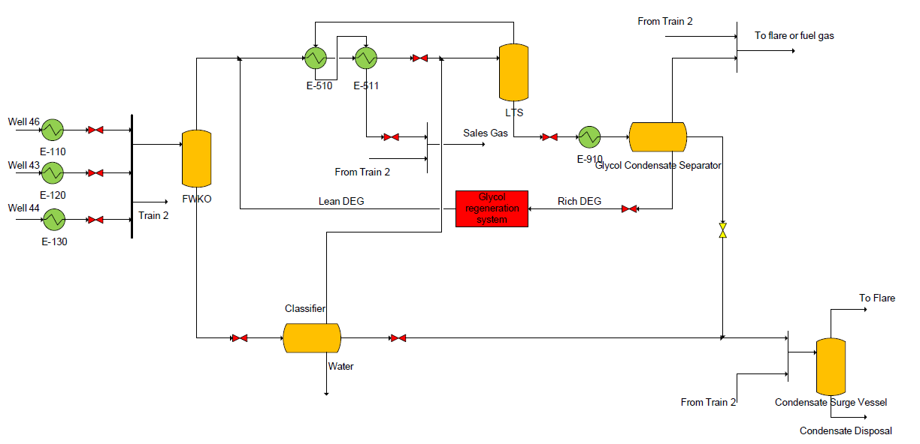

Figure 1-1: Obigbo NAG Plant Process Flow Diagram

**Gas Handling**

Well stream NAG saturated with water at 104 bar is transported via flowlines from wells 43, 44 and 46 to the plant inlet manifold. If required, the three Well streams are heated to a temperature of 43.5oC in a flowline gas-water heat exchanger to melt any hydrates that may have formed. However, the water bath heater has not been in used as the treat of hydrate is low and non-existent.

**Liquid Handling**

Liquid from the FWKO which is mainly water and a small amount of condensate is routed to the FLKO which operates at the same pressure as LTS vessel (~60 bar). Any vapours that are flashed off in the FLKO are sent back to the gas train and the liquids proceed to the condensate surge vessel. Substantially more hydrocarbon liquid along with the glycol-water solution is generated in the LTS vessel due to gas chilling. The glycol-condensate mixture from the LTS vessel is routed to a three-phase glycol-condensate separator operating at 11 bar and 27oC. The condensate from this separator is mixed with liquid from the FWKO and sent to the surge vessel. The flash gas is either used as fuel or flared. The glycol-water solution (also known as rich glycol) is routed to the glycol regeneration system.

The condensate is stabilized for export via the surge vessel which reduces its pressure to around 1.5 bar. The offgas from the surge vessel is flared while the stabilized condensate is mixed with oil from the flowstation and exported to the Bonny terminal. Figure 1-1 provides an overview of the condensate handling system.

**Glycol Regeneration System**

The purpose of the glycol regeneration system is to remove the water from the glycol solution which dropped out owing to gas dewpointing.

The rich glycol stream from the glycol condensate separator is flashed to atmospheric pressure and then heated using the rich glycol - lean glycol exchanger and glycol reboiler to a temperature of around 90oC. This heating allows water to be boiled off from the rich glycol solution in the glycol reboiler column. Water vapour is discharged locally to the atmosphere. The resulting lean glycol which is at 75 % glycol by weight and ~110oC is cooled using rich - lean glycol exchanger to around 45oC and sent to the glycol accumulator which acts as buffer storage for glycol in the system. The glycol is then pumped from the accumulator into the gas train upstream of the gas-gas exchanger at ~100 bar using the glycol injection pumps. The glycol regeneration system has not been in used because the treat for hydrate is non-existent now.

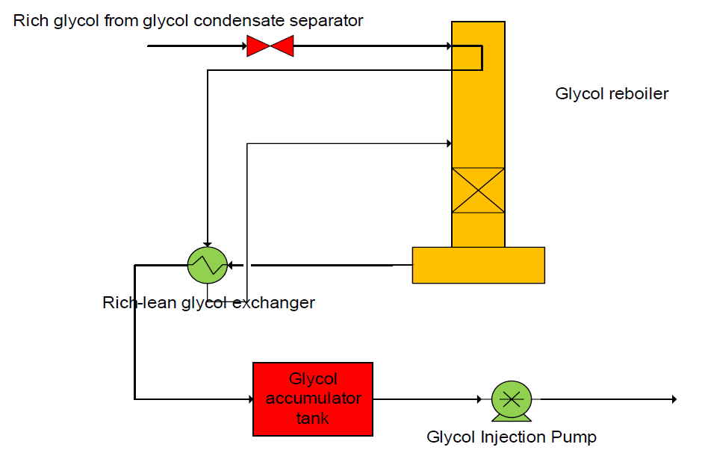

Figure 1-2: Glycol Regeneration System Process Flow Diagram

# DATA GATHERING

The major sources for the data used in this study are:

* OBGN W44 and W46 MRT datasheet
* Production Chemistry composition analysis result for W46T
* Data from the NAG plant control room
* Equipment mechanical datasheet for Obigbo NAG plant

## DEWPOINT MEASUREMENT

As part of the required input for the calibration of the UNISIM model for the NAG plant, the compositional analysis results carried out for W46 on 21st December 2016 were used to calibrate the process simulation model. The result was obtained at inlet manifold pressure of 105 barg.

The results obtained are given in Tables 2.1 below:

|  |  |
| --- | --- |
| **Components** | **Mol%** |
| CO2 | 1.8 |
| O2 | - |
| N2 | 0.82 |
| C1 | 89.63 |
| C2 | 4.34 |
| C3 | 1.54 |
| iC4 | 0.89 |
| nC4 | 0.52 |
| iC5 | 0.21 |
| nC5 | 0.13 |
| C6 | 0.07 |
| C7 | 0.04 |
| C8 | 0.01 |
| C9 | - |
| **Total** | **100** |
| Molecular Weight | 18.56 |
| Gas Gravity (Air = 1) | 0.6409 |
| Heptanes Plus (Mole %) | 0.05 |
| Molecular Weight of Heptanes | 100.2 |
| Heat Content (Btu/ft3) | 981.64 |

Also, the production data from the NAG plant manifold and the LTS vessel were trended between 16th March and 23rd March 2017 to obtain hard values for GOR observed in the plant for the calibration of the process simulation model.

The results obtained from the plant are summarized in Table 2-2 below:

|  |  |  |  |  |  |  |  |  |
| --- | --- | --- | --- | --- | --- | --- | --- | --- |
| **Date** | **W44T Pressure, barg** | **W44T Temperature, OC** | **W46T Pressure, barg** | **W46T Temperature, OC** | **Production Header, barg** | **Flowrate, MMscfd** | **LTS Vessel Pressure, barg** | **Liquid Produced, bpd** |
| 16/03/2017 | 133 | 33 | 105 | 30 | 100 | 6.33 | 48 | 225.00 |
| 17/03/2017 | 135 | 33 | No flow | 31 | 100 | 4.69 | 42 | 175.20 |
| 18/03/2017 | 136 | 34 | No flow | 30 | 100 | 7.27 | 58.7 | 341.22 |
| 19/03/2017 | 136 | 34 | No flow | 30 | 100 | 5.98 | 67.5 | 230.00 |
| 20/03/2017 | 148 | 29 | 112 | 33 | 101 | 3.86 | 70 | 20.00 |
| 21/03/2017 | 156 | 37 | 114 | 33 | 100 | 10.46 | 67.9 | 449.03 |
| 22/03/2017 | 130 | 36 | 116 | 32 | 101 | 13.81 | 67.8 | 600.00 |
| 23/03/2017 | 125 | 35 | 106 | 32 | 100 | 14.02 | 72 | 641.49 |

# STUDY METHODOLOGY

The study methodology is aimed at establishing the feasibility of producing the Obigbo NAG Wells to the AGG at 70barg manifold pressure to the TEG Contactor (ONPO-1) and further staged pressure reduction to 8 barg to second stage compressor suction (ONPO-2). This is done by a combination of the following:

* Estimation of the expected water and hydrocarbon dewpoint from ONPO-1 and ONPO-2 using UNISIM
* Comparism of the water and hydrocarbon dewpoint values from ONPO-1 and ONPO-2.
* Comparism of the modifications required to achieve ONPO-1 and ONPO-2.
* Effect of both proposed configurations on NAG plant capacities.

## Process Simulation Model

The NAG plant UNISIM model was developed as designed with the data sheet of all installed equipment and current plant operating parameters and feed stream compositional data. The model was updated with liquid and gas rates data trended from the 16th to 23rd March 2017.

The snapshot of the NAG UNISIM model is given below:

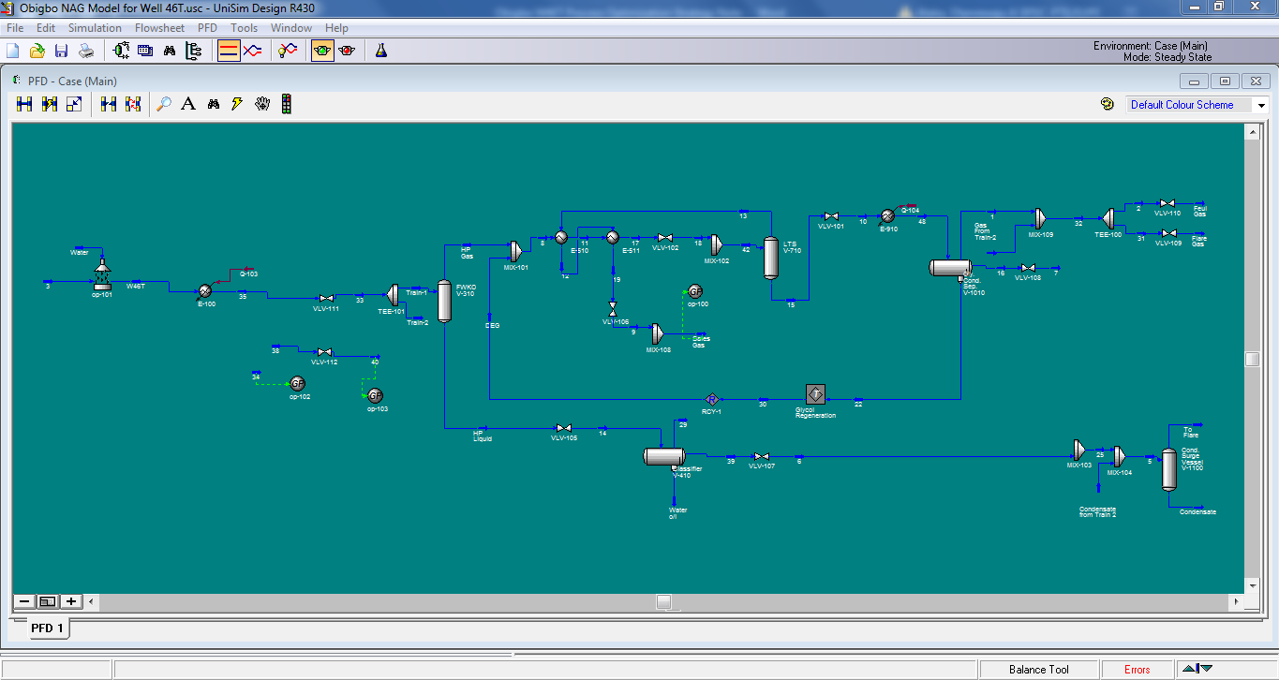

Figure 3-1: UNISIM Model for Obigbo NAG Plant

## Bulk Production from the NAG Wells into AGG Plant (Upstream of TEG Contactor at 70 barg (ONPO-1)

Bulk Production from NAG wells into the AGG plant (upstream glycol contactor) at 70barg, utilizing AGG excess capacity thereby significantly reducing OPEX of the NAG plant operations.

The schematic of the proposed modification is shown below:

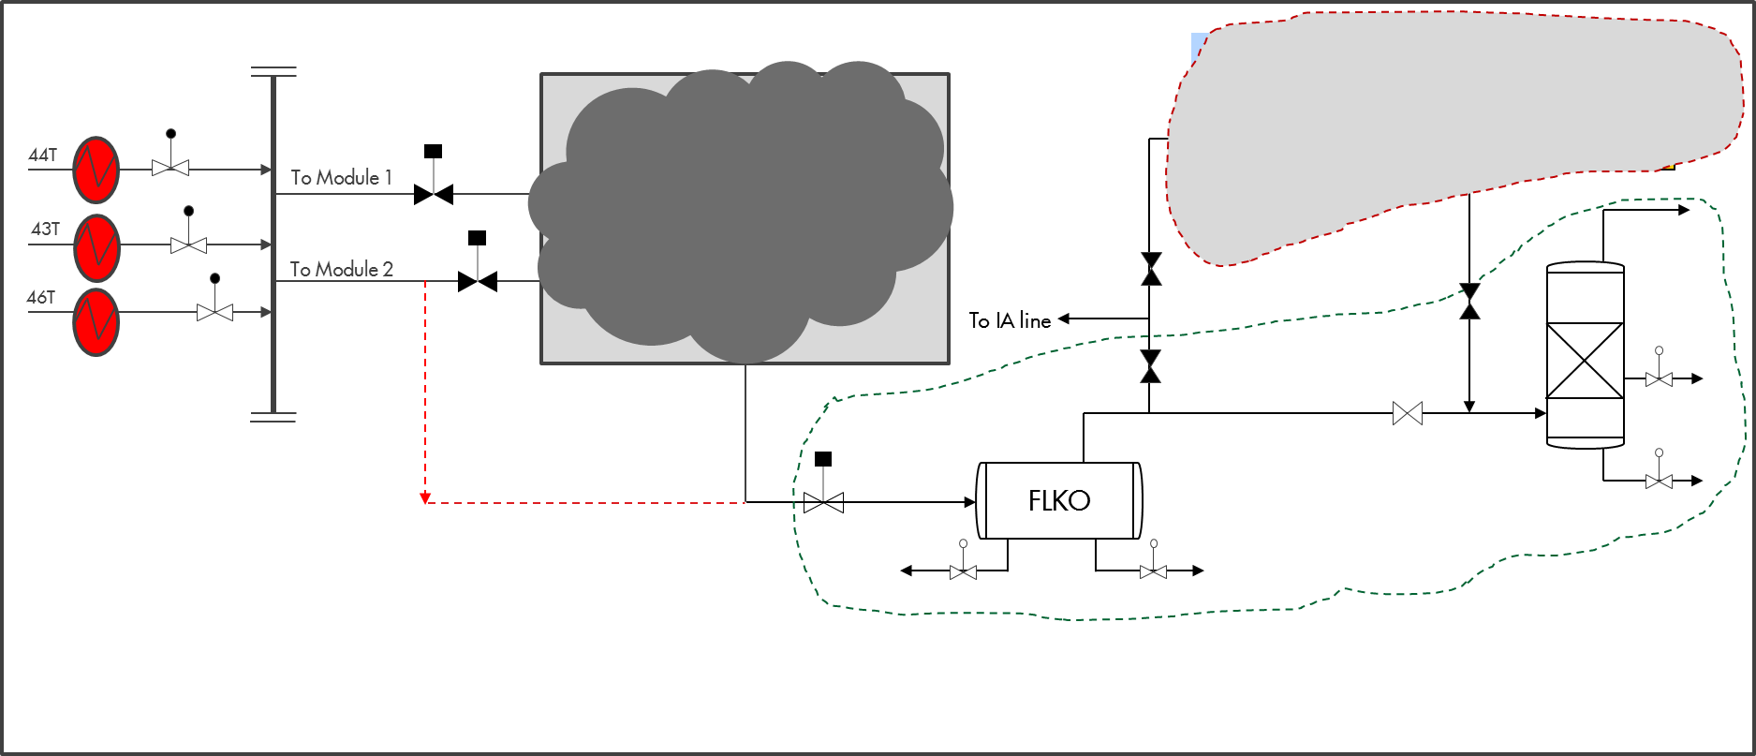

Figure 3-2: Process Schematic for ONPO-1

The modifications required are:

* Tie in from Production Header at NAG plant (via inlet to Module 2) to export line:
  + Remove shutdown valve SDV320 upstream of Module 2 FLKO and blind flange the downstream connection.
  + Remove manual valve on the LTS outlet & blind flange the upstream connection.
  + Short piece connection between Module 2 FLKO inlet (6” line) and the LTS outlet (8” line) which ties into the export gas header (16” line).
* Spade off module 1 FLKO inlet and LTS outlet.
* Pressure drop from 100barg to 70barg using each FCV at NAG inlet flowlines.
* Remove FLKO from NAG module 2 and install in SEM (space around the Agbada inlet line at SEM, opposite the Glycol contactor at AGG) to act as a scrubber.
* Install new pipeline from the NAG interfield supply (around 10” manual valve) to the new scrubber (EX-NAG FLKO) at the SEM
* Tie Gas outlet of the new scrubber to downstream of the AGG contactor inlet shutdown valve (26UZ-351), before the glycol contactor thus ensuring production during TNP outage.
* Install SDV on gas outlet of the new scrubber upstream glycol contactor to enable isolation of NAG wells and tie into AGG ESD and the relevant OSD1 that closes the AGG Export shutdown valve(26UZ-355).
* Install BDV for the new scrubber and tie to AGG ESD.
* Install LCV for the new scrubber and tie to the AGG PCS.
* Liquid outlet of the new scrubber tied to the AGG process drain vessel.
* Install two meters on the new scrubber for gas and liquid measurements.
* Program the AGG PCS to have a separate OSD3 for the NAG production.
* Use existing instrument air line from AGG to NAG to feed the FCV’s and the SDV’s at NAG eliminating need to run Instrument Air compressor at NAG.
* Install a JB at NAG inlet manifold that will reroute inlet manifold and production header instrumentations & control systems to AGG PAS.
* Install cabling from the new scrubber and tie to AGG PCS for the gas & liquid measurements as well as the level control.
* Install manual isolation valve on the gas supply from NAG at the SEM to prevent the direct access of NAG wells to IA line.
* Use existing F&G cable terminations (running from SEM) at the condensate stabilization unit to run F&G system for the flowlines at NAG.
* Use existing F&G cable terminations (running from SEM) at the condensate stabilization unit to run F&G system for the flowlines at NAG

**Challenge**:

* Fuel gas to run the NAG gen which powers FOC, FS, JTF camp and community cold room.

If NAG gen remains, spill over skid at NAG will still be utilized thereby keeping the flare continuously up.

Option to resolve this:

* + Pipe Fuel gas from AGG to the NAG gen
* Liquid handling during TNP outage.

Resolution:

* + Move the existing NAG plant surge vessel to the SEM to serve as a liquid holding tank.
  + Bring in an extra vessel to serve as liquid holding tank for further endurance.
  + Tie the liquid outlet to the closed drain at AGG.
* Construction risks – piping and cabling road crossing

Pros:

* Reduced cost of operations & maintenance as NAG plant will only be a manifold
* Improvement in the quality of gas due to functional gas dehydration system in Obigbo AGG.
* Reduction in GHG (fugitives) emissions due to the elimination of Saver pit operation at the NAG plant.
* Tie-in of NAG controls to AGG DCS, leading to cost savings from proposed NAG DCS upgrade & eliminating the problem of obsolescence of NAG control system
* Continued Production during TNP outage

Cons:

* Possible water flooding of the TEG contactor because of high water content in NAG wells which could affect dewpoint.

## Production of NAG Wells at 70 barg and Consequent Pressure Reduction to 8 barg (ONPO-2)

Production of NAG wells at 70 barg manifold pressure using the FCVs at the inlet to choke the flow then JT valve to 30barg and subsequently drop the pressure to 8barg to feed HP slug catcher at the AGG.

This will entail a routing of the feed gas from the NAG manifold to the existing sales line and diverting it from the SEM to the HP slugcatcher at the AGG plant.

The schematic of the proposed modification is shown below:

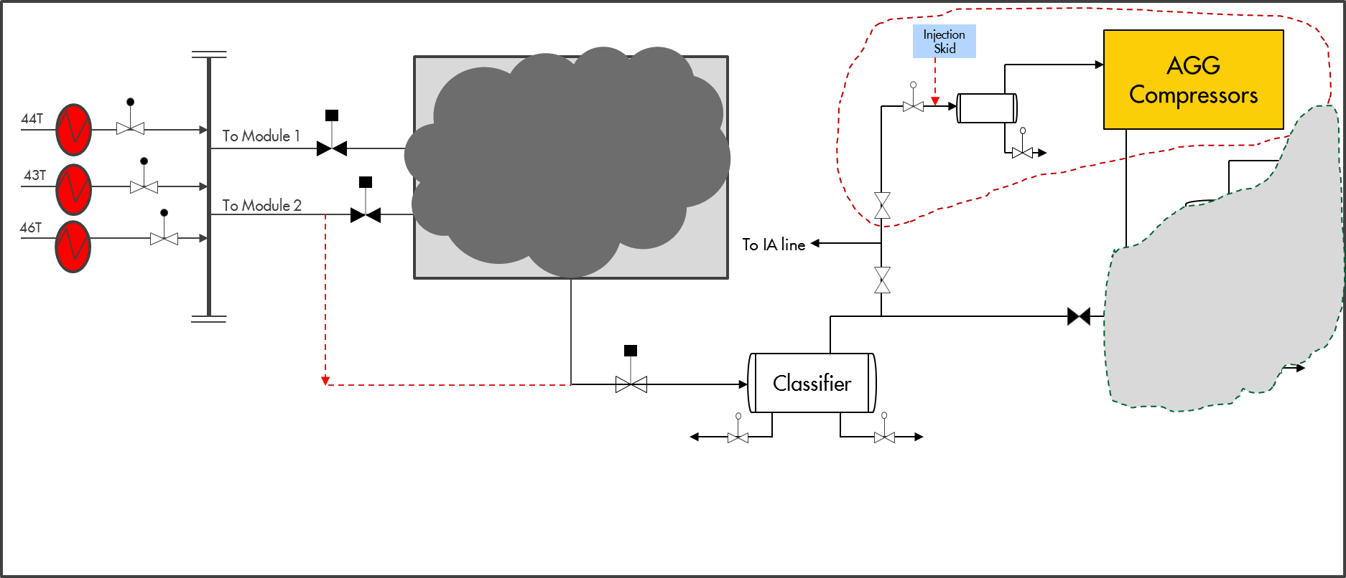

Figure 3-3: Process Schematic for ONPO-2

The modifications required are:

* Tie in from Production Header at NAG plant (via inlet to Module 2) to export line:
  + Remove shutdown valve SDV320 upstream of Module 2 FLKO and blind flange the downstream connection.
  + Remove manual valve on the LTS outlet & blind flange the upstream connection.
  + Short piece connection between Module 2 FLKO inlet (6” line) and the LTS outlet (8” line) which ties into the export gas header (16” line).
* Spade off module 1 FLKO inlet and LTS outlet.
* Pressure drop from 100barg to 70barg using each FCV at NAG inlet flowlines.
* Install new pipeline from the NAG interfield supply (around 10” manual valve) to the new scrubber (EX-NAG FLKO) at the SEM
* Pressure drop from 70barg to 30barg using a JT valve at new scrubber outlet.
* Install an intermediate pressure vessel between the new scrubber outlet and HP slug catcher
* Install PCV upstream of the HP slug catcher to drop the pressure from 30 to 8barg.
* Install SDV between the PCV and the HP slug catcher to enable isolation of NAG wells and tie into AGG ESD and any OSD level that stops the turbine.
* Overpressure protection system for the HP slug catcher at the AG plant.
* Remove FLKO from NAG module 2 and install in SEM (space around the Agbada inlet line at SEM, opposite the Glycol contactor at AGG).
* Install 3 manual valves (one by-pass and two isolation) for flow diversion to the new scrubber (Ex-NAG FLKO) during well testing.
* Install meters on the new scrubber for gas and liquid measurements.
* Install BDV for the new scrubber and tie to AGG ESD.
* Install LCV for the new scrubber and tie to the AGG PCS.
* Liquid outlet of the new scrubber tied to the AGG process drain.
* Program the AGG PCS to have a separate OSD3 for the new scrubber.
* Use existing instrument air line from AGG to NAG to feed the FCVs and the SDVs at NAG eliminating need to run Instrument Air compressor at NAG.
* Install a JB at NAG inlet manifold that will reroute inlet manifold and production header instrumentations & control systems to AGG PAS.
* Install cabling from the new scrubber and tie to AGG PCS for the gas & liquid measurements as well as the level control.
* Install manual isolation valve on the gas supply from NAG at the SEM to prevent the direct access of NAG wells to IA line.
* Use existing F&G cable terminations (running from SEM) at the condensate stabilization unit to run F&G system for the flowlines at NAG.

**Challenge**

* Fuel gas to run the NAG gen which powers FOC, FS, JTF camp and community cold room.

If NAG gen remains, spill over skid at NAG will still be utilized thereby keeping the flare continuously up.

Option to resolve this:

* + Pipe Fuel gas from AGG to the NAG gen
* Construction risks – piping and cabling road crossing

**Pros**

* Extend the production life of NAG wells, increase volume by circa 10-15 bscf of gas and maximize ultimate recovery.
* Increase in AG compressor throughput and reduction/elimination of compressor recycling thereby extending the compressor life
* Reduced cost of operations & maintenance as NAG plant will only be a manifold
* Improvement in the quality of gas due to functional gas dehydration system in Obigbo AGG.
* Reduction in GHG (fugitives) emissions due to the elimination of Saver pit operation at the NAG plant.
* Tie-in of NAG controls to AGG DCS, leading to cost savings from proposed NAG DCS upgrade & eliminating the problem of obsolescence of NAG control system
* AGG still running with gas from NAG wells during TNP outage

**Cons**

* NAG is totally dependent on AGG availability
* Liquid handling during TNP outage as the FS is down.

## Hybrid of ONPO-1 and ONPO-2

The hybrid option will involve the combination of ONPO-1 and ONPO-2 in a phased manner. This will involve a bulk production from NAG wells into the AGG plant at 70 barg for Phase I with a tie-off at the outlet of the FLKO for Phase II which is basically ONPO-2.

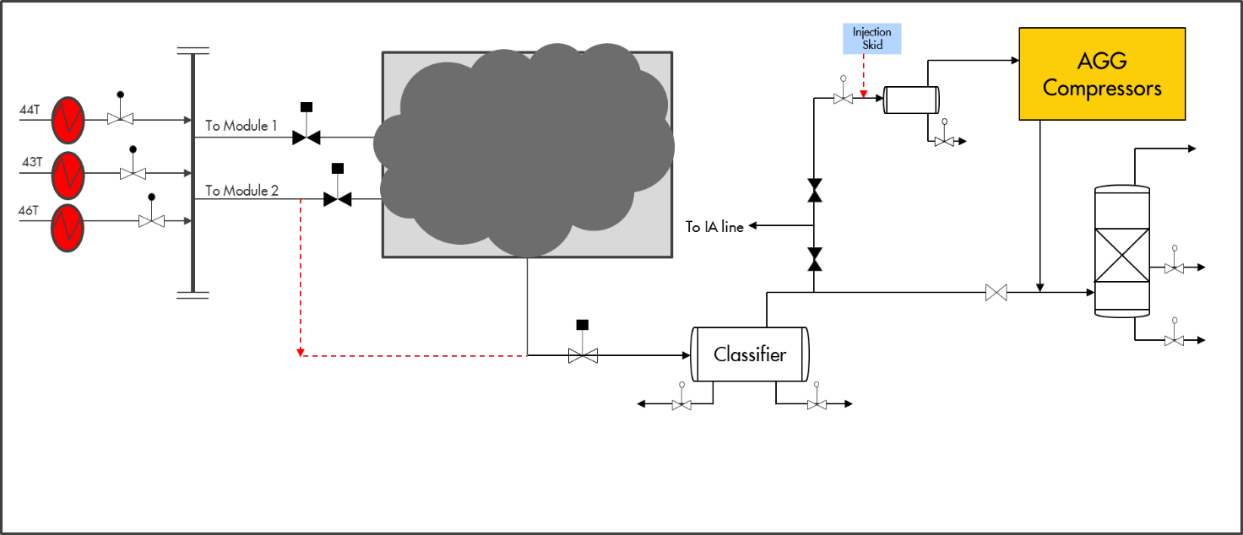

Figure 3-4: Process Schematic for Hybrid

**Modifications required:**

* Combination of ONPO-1 and ONPO-2 options.

**Challenge:**

* Combination of ONPO-1 and ONPO-2 options.

**Pros**

* Reduced cost of operations & maintenance as NAG plant will only be a manifold
* Improvement in the quality of gas due to functional gas dehydration system in Obigbo AGG.
* Extend the production life of NAG wells, increase volume and maximize ultimate recovery.
* Increase in AG compressor throughput and reduction/elimination of compressor recycling
* Reduction in GHG (fugitives) emissions due to the elimination of Saver pit operation at the NAG plant.
* Tie-in of NAG controls to AGG DCS, leading to cost savings from proposed NAG DCS upgrade & eliminating the problem of obsolescence of NAG control system
* Continued Production during TNP outage

**Cons**

* Liquid handling during TNP outage

# CONCEPT SELECTION

## PROCESS SIMULATION

## The results from the UNISIM sensitivities carried out for both configurations (ONPO-1 and ONPO-2) are summarized in the table below:

|  |  |  |  |
| --- | --- | --- | --- |
| **Options** | **Hydrocarbon Dewpoint** | **Water Dewpoint** | **Residual Water, lb/MMscf** |
| Current Process | -72 | -4.2 | 4.4 |
| ONPO-1 | -68 | -6.1 | 3.86 |
| ONPO-2 | -68.7 | -1.55 | 5.3 |

From the Table 4-1 above, the expected water and hydrocarbon dewpoint values for both ONPO-1 and ONPO-2 are within the dewpoint specifications for the plant (15oC / 15oC).

Also, the threat for hydrate formation for ONPO-2 is high and could be significantly higher when the reserve decline and there is an increase in water production from the well. The configuration proposed for ONPO-2 will include a heater and JT-LTS system with a MEG injection skid for hydrate control.

The estimated liquid production rate from the model is approximately 500 bpd at full production from all the Wells and >100 bpd (5 MMscfd gas rate) during TNP outage.

## RESULT AND ANALYSIS

The three proposed concepts (ONPO-1, ONPO-2 and Hybrid) were analyzed to select the best option for the rerouting of the NAG wells to the AGG plant. The ranking of the concepts was carried out by a multidisciplinary team of Operations, Maintenance, Asset Engineering and Discipline Engineering. The options were compared using the following selection criteria and weighting based the estimated impact of each criteria on the proposed rerouting:

* Cost of execution of concept
* Do ability / Difficulty (speed, percentage offsite construction, weather dependence etc.)
* Availability (Dependency of NAG wells on AGG availability)
* TNP Outage (NAG wells flowing to the AGG plant during TNP outage)
* Dewpoint
* OPEX
* Production (Potential production increase from modification)
* AGG recycle (Impact on AGG recycling)



The concept selection matrix is shown in Table 4.2 below:

Table 4.2. Concept Selection Matrix for the Available Options for Rerouting Obigbo NAG wells to the AGG Plant



The selection of the preferred option from the matrix above is based on the option with the highest total score in the order ONPO-1 > ONPO-2 > Hybrid. From the matrix, ONPO-1 will be the most preferred option due to the ease of execution and minimal impact on the facility during TNP outage. However, the multidisciplinary team proposed to have the hybrid option in a phased approach to optimize the production as after decline of reservoir below 70barg the ONPO-1 will no longer be feasible but ONPO-2 option will support production based on the reservoir pressure:

Phase I; Execution of ONPO-1 with tie-in for future connection upstream the FLKO receiving the NAG wells into the AGG plant.

Phase II; Execution of ONPO-2 during depletion of NAG wells pressure using the tie-in created from ONPO-1 to receive the NAG wells at a lower pressure.

## Obigbo AGG Plant (TEG Contactor) Capacity Review

The Obigbo AGG Glycol Contactor is a conventional vertical vessel incorporating lower liquid knockout sections and upper glycol structured packing contacting sections. The gas enters the lower section in which any carried over hydrocarbon liquids are removed from the gas to prevent contamination and degradation of the dehydration process or the glycol regeneration system. Liquid from the bottom of the contactor is routed to process drain. The gas flows upwards into the contacting section through a chimney tray, which collects glycol and prevents loss to the knockout section. The gas is contacted counter-currently with the lean glycol in the contacting section and exits the Contractor through a demister.

Table 4.3: Glycol Contactor Details

|  |  |
| --- | --- |
| Vessel Size | 1.066mm (Dia.) x 9.144mm (S/S) |
| Nozzles | 10” gas inlet, 10” gas outlet, 3” condensate outlet (with vortex breaker), 2” lean TEG inlet (with glycol distributor),  2” rich TEG outlet |
| Operating Pressure (barg) | 75.8 |
| Operating Temperature (Max/Normal/Min) OC | 70/41/30 |
| Relief Valve | 26 RV 351 (set pressure = 85barg) |
| Nameplate Capacity (MMscfd) | 68 |

# TEG Contactor Operating Envelope

Figure 4.18 TEG Contactor Operating Envelope

Table 4.4 TEG Contactor Capacity Constraints

|  |  |  |
| --- | --- | --- |
| **Variable** | **Capacity** | |
| **(Mbpd)** | **(MMscfd)** |
| Gas Limit Imposed by Water Load |  | 154.41 |
| Gas Handling |  | 149.7 |
| Liquid Inplot Piping | 4.71 |  |
| Gas Inplot Piping |  | 285.51 |
| Rich TEG Outlet Nozzle | 1.18 |  |
| Gas Outlet Nozzle |  | 112.27 |
| TEG Inlet Level Control Valve | 1.28 |  |

The rating results show that the Contractor has sufficient gas and liquid handling capacities to handle extra production (circa 25 MMscfd) from the NAG plant. The minimum design rate for the contactor is 20 MMscfd. However, the expected rate during TNP outage into the contactor will be ca. 5 MMscfd. This can have a potential impact on the dewpoint. Further performance analysis at lower contactor rate should be done as part of the design.

## TECHNICAL PROPOSAL

## **Management of Change Approval**

The proposal to reroute NAG wells through the AGG plant dehydration system before export will be submitted to CCMP for approval.

## **Design Works and Deliverables**

Detailed design will be carried out and AFC drawings produced for the NAG to AGG rerouting.

The design will be such that there will be minimum impact on facility deferment through initiatives such as maximizing off-site fabrication.

## **Deliverables/Activities**

### General

* Tie in from Production Header at NAG plant (via inlet to Module 2) to export line
* Disconnection and blind-off connections to NAG modules
* Relocate the FLKO from NAG module 2 and installation at Sales Manifold area.
* Integration, interconnectivity of piping systems and Instrumentation works.

### Process Engineering Deliverables

* Approve for Construction Drawings (UEFS, UFS)
* Issuance of demolition drawings and modification drawings (Tie-in)
* Issuance of process design report

### Mechanical (Piping) Deliverables

* Pipe stress analysis report
* Update of relevant piping documents e.g. plot plan and piping general arrangement drawings and Isometric drawings
* Verification of existing pipe support and update of pipe support drawing and schedule (if required)
* Demolition drawings and Tie-in schedule
* MTO
* Constructability review

### Civil Engineering Deliverables

* Civil/Structural design philosophies & specifications
* Plot plans & layout Drawings
* Equipment foundation Layouts, sections & details
* Pipe support foundation plans & structural details

### PACO Deliverables

* Design datasheet and specifications
* Hook-Up details
* Cause & Effect Matrix update
* Control narrative

### Electrical Engineering Deliverables

* Design calculations
* Single line diagrams update
* Layout and connection Drawings
* Update of the facility’s load Lists

### Technical Safety

* HAZOP

## **Schedule**

Design work to produce approved for construction drawings is expected to last for a month. Fabrication will be done thereafter.

# CONCLUSION & RECOMMENDATIONS

Analysis of the concepts show that rerouting the wells through the AGG plant dehydration system before export will improve NAG plant export gas dew point and meet customer specification. The AGG excess capacity will be utitlized and OPEX reduced as the NAG plant will operate as a manifold. Producing W46T at lower FTHP will extend the production life and maximize ultimate recovery from the reservoir with incremental recoverable volumes of circa15 Bscf.

Of the three concepts identified, ONPO-1 will be the most preferred option due to the ease of execution and minimal impact on the facility during TNP outage. However, the multidisciplinary team proposed to have the hybrid option but in a phased approach:

Phase I; Execution of ONPO-1 with tie-in for future connection upstream the FLKO receiving the NAG wells into the AGG plant.

Phase II; Execution of ONPO-2 during depletion of NAG wells pressure using the tie-in created from ONPO-1 to receive the NAG wells at a lower pressure.

The following actions are recommended for the values highlighted in this report to be derived:

* Detailed Cost Estimate
* Project Schedule
* Detailed Design and AFC drawings
* Management of Change approval
* Early contractor engagements for fabrication

# REFERENCES

* GS.09.54603, Obigbo North NAG Plant and Water Injection Plant – Simulation and Operating Envelopes, 2009.

**APPENDIX**

* Marked up PEFS for Phase I